

**GenAi Exchange Hackethon 2025**

**( Google Cloud )**

**Challenge : Personalized Career & Skills Advisor**

* **Live Project Link :**

Challenge : <https://shyamdesale.github.io/personalized-ai-career-skills-advisor/>

* **Challenge : Personalized Career & Skills Advisor :-**

1. **Overview :-**

# Empowering Students with AI-Driven Career Intelligence-

In today’s fast-changing job landscape, students often struggle to align their skills with future opportunities. Our project – **CodeRush : Personalized Career and Skills Advisor** - bridges this gap using generative AI and Google Cloud technologies to deliver tailored career guidance at scale. This intelligent platform analyzes user data - resumes, LinkedIn profiles, quiz results - to build a dynamic skill map. It then recommends personalized career paths, identifies skill gaps, and curates learning resources to close those gaps. With real-time insights into industry trends and a conversational AI interface, CodeRush transforms career planning into an engaging, data-driven experience. Whether you're a student in a Tier 2 city or a professional seeking a pivot, CodeRush makes career decisions smarter, faster, and more future-ready.

**2. Problem Statement :-**

In India and across the globe, millions of students graduate each year without a clear understanding of how their skills align with real-world career opportunities. Traditional career counseling is often generic, inaccessible, or outdated—especially for students in Tier 2 and Tier 3 cities. As industries evolve rapidly with AI, data science, and emerging tech, the gap between academic learning and market demand continues to widen.

- Students face key challenges:

* Lack of personalized career guidance based on their actual skills and interests
* Difficulty identifying skill gaps and knowing what to learn next
* Limited access to mentorship, industry insights, and future job trends
* Overwhelming choices with no clear roadmap to success

**There is an urgent need for an intelligent, scalable solution that empowers students to make informed, personalized career decisions—based on data, not guesswork.**

**3. Solution & Features :-**

💡 Solution -

Our platform, CodeRush, offers a smart, scalable solution to the career confusion faced by students and professionals. By leveraging Google Cloud’s generative AI, CodeRush transforms fragmented data—resumes, LinkedIn profiles, quiz results—into a personalized career roadmap. It acts as a virtual career mentor, delivering real-time insights, skill analysis, and tailored recommendations to help users make informed decisions.

Whether you're a student exploring options or a professional planning a pivot, CodeRush adapts to your profile and guides you toward future-ready opportunities.

🌟 Key Features -

1. 🧠 AI-Powered Skill Profiler
   * Automatically detects technical and soft skills from resumes, LinkedIn, and quizzes
   * Builds a personalized skill map with strengths and gaps
2. 🚀 Career Path Recommendations
   * Suggests ideal career tracks based on user profile and market trends
   * Includes niche roles like AI Ethics Analyst, Prompt Engineer, and Data Product Manager
3. 📊 Skill Gap Analysis
   * Compares user skills with industry demand
   * Recommends targeted courses and challenges to close gaps
4. 🎯 Learning Hub Integration
   * Curates personalized courses from trusted platforms
   * Tracks progress with visual dashboards and gamified challenges
5. 💬 Generative AI Chatbot
   * Offers real-time career advice, interview prep, and resume tips
   * Supports multilingual interaction (English, Hindi, Marathi, Urdu)
6. 📄 AI Resume & Cover Letter Builder
   * Generates optimized resumes and cover letters tailored to chosen career paths
   * Uses generative AI to highlight relevant achievements and skills
7. 📈 Future Jobs & Trends Explorer
   * Provides insights into emerging roles and in-demand skills
   * Updates dynamically using real-time labor market data
8. 🤝 Mentor Connect (Beta)

* Matches users with industry mentors based on interests and goals
* Facilitates Q&A sessions and career guidance
  1. **Impact & Future Scope :-**

🎯 Impact

* Empowering Students Nationwide  
  CodeRush democratizes career guidance by making intelligent, personalized advice accessible to students across Tier 2 and Tier 3 cities-bridging the gap between potential and opportunity.
* Data-Driven Decision Making  
  By analyzing real-time skill trends and individual profiles, users make smarter career choices, reducing trial-and-error and boosting confidence.
* Enhanced Employability  
  With targeted skill development and resume optimization, users are better prepared for interviews, internships, and job placements.
* Institutional Adoption  
  Colleges and universities can integrate CodeRush into career counseling programs, improving placement outcomes and student satisfaction.
* Scalable & Inclusive  
  Supports multilingual interaction and adapts to diverse educational backgrounds, ensuring no student is left behind.

🔮 Future Scope

* AI Mentor Matching  
  Expand the Mentor Connect feature to include AI-driven mentor matchmaking based on goals, personality traits, and learning styles.
* Voice-Enabled Career Coaching  
  Integrate advanced voice support for hands-free, conversational career guidance—ideal for mobile-first users.
* Gamified Learning & Career Challenges  
  Introduce career quests, badges, and leaderboards to make skill-building engaging and competitive.
* Integration with Job Portals & Recruiters  
  Enable direct application to jobs and internships based on AI-matched profiles and resume scores.
* Global Expansion  
  Localize the platform for international markets, adapting to regional job trends, languages, and educational systems.
* AI Career Forecasting  
  Use predictive modeling to forecast future roles and skill demands, helping users stay ahead of the curve.
  1. **Demo Screenshots :-**

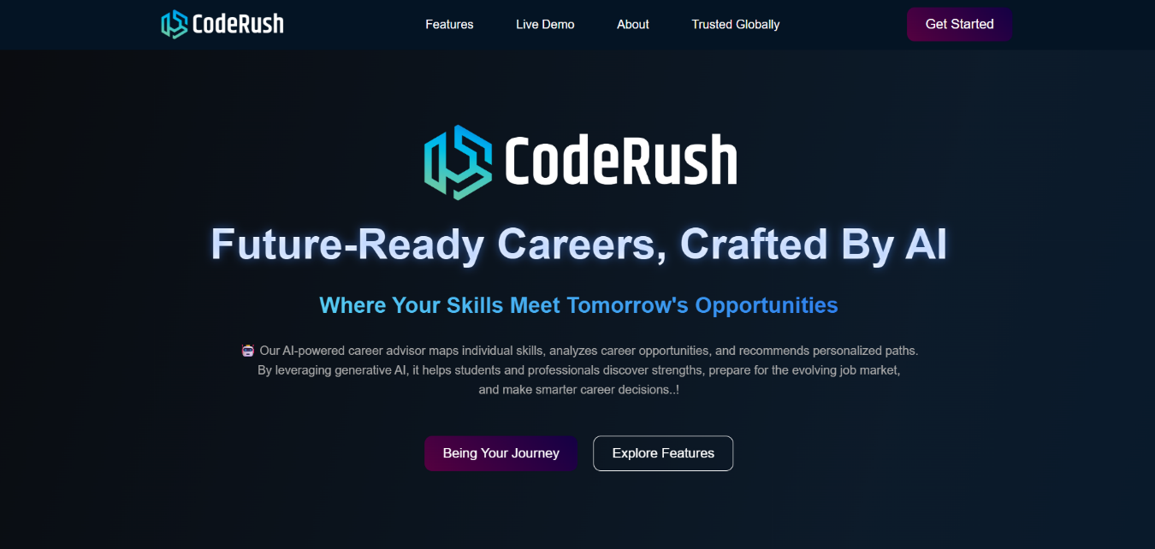

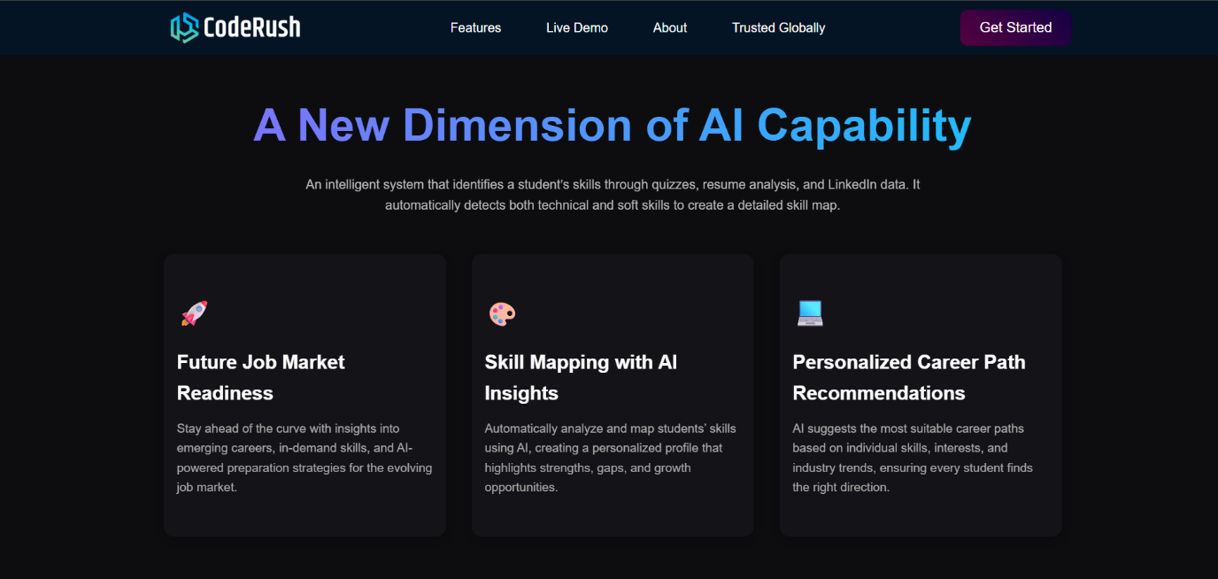

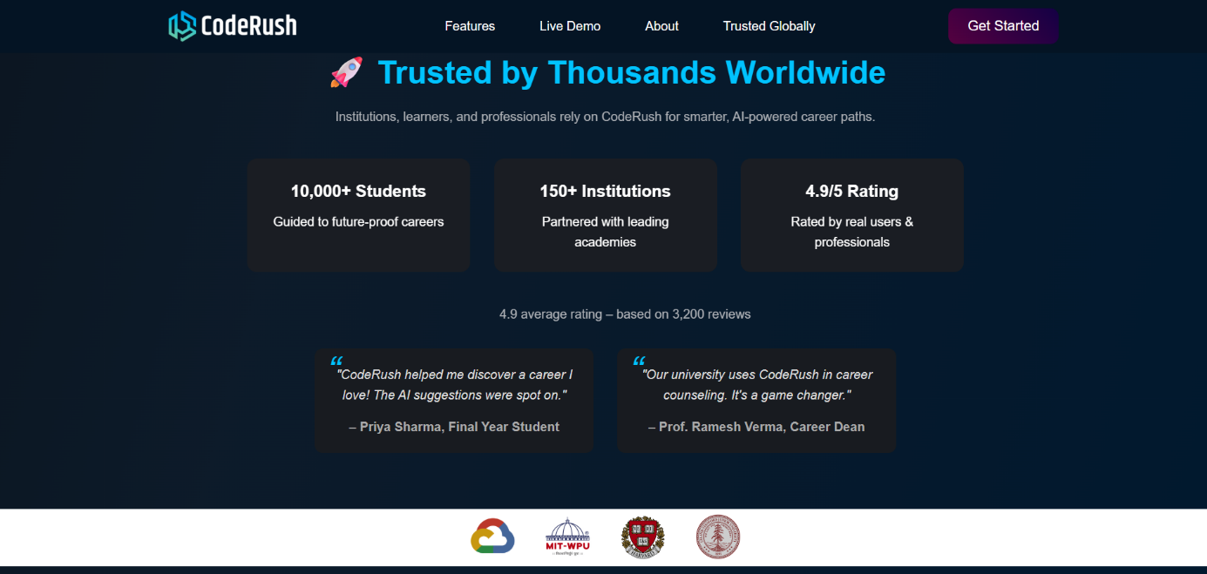

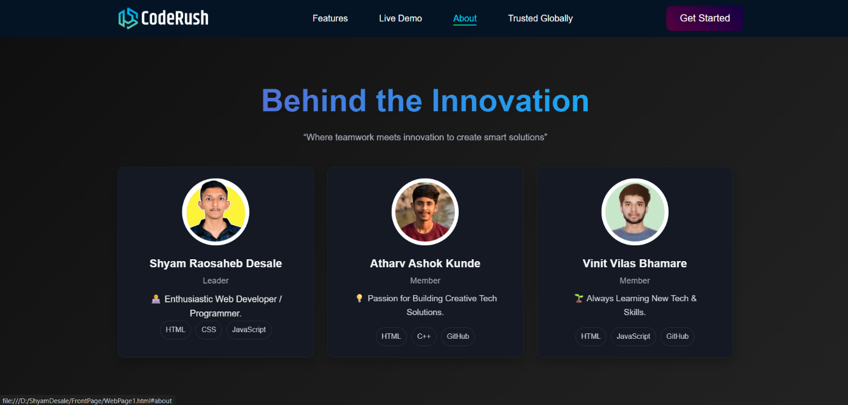

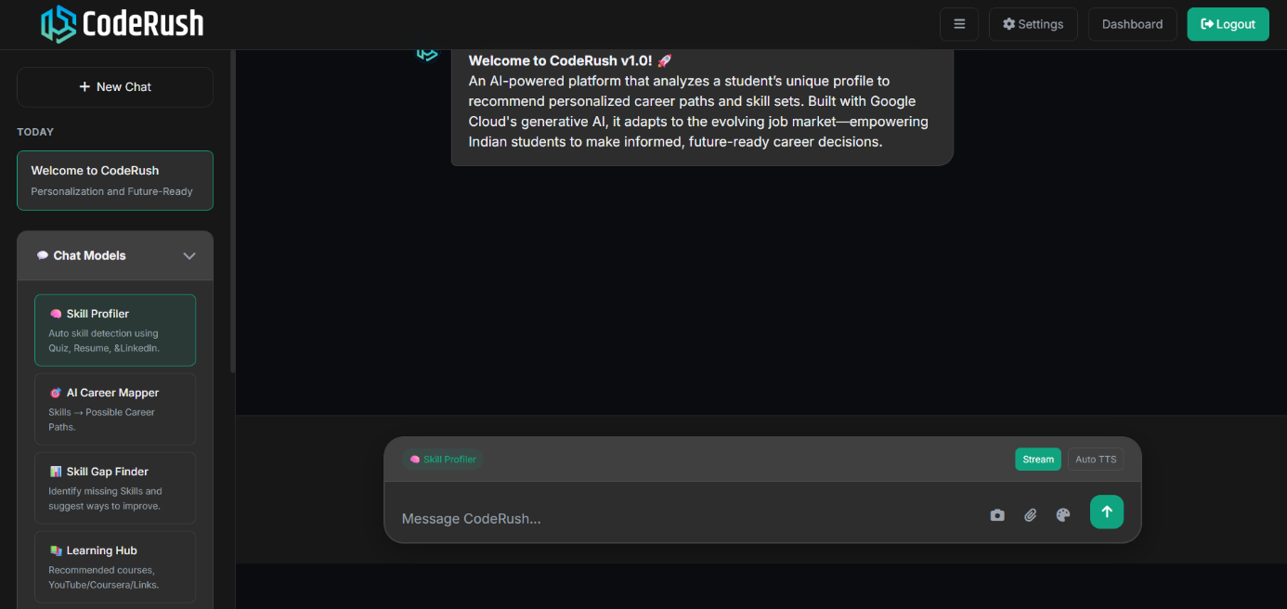

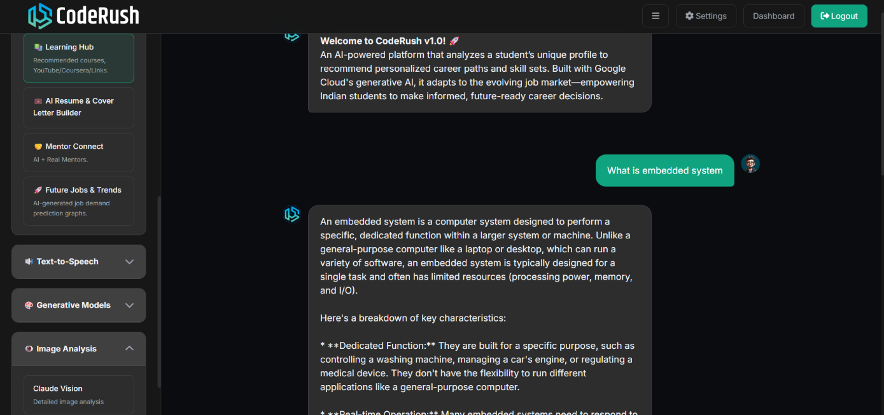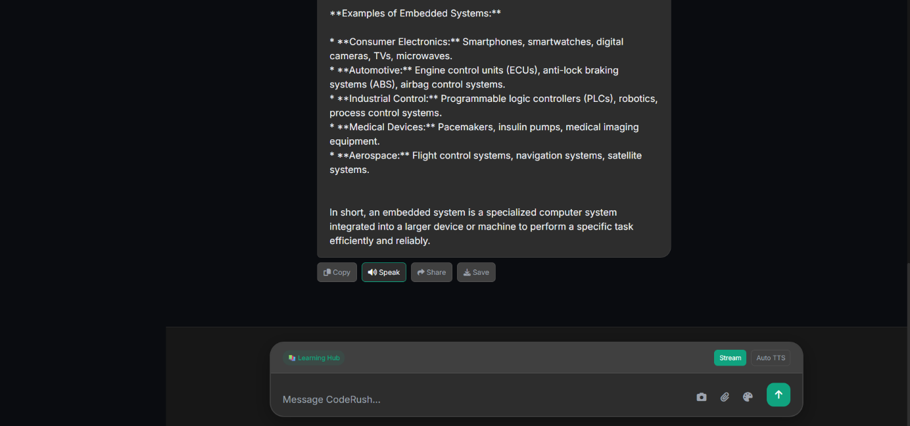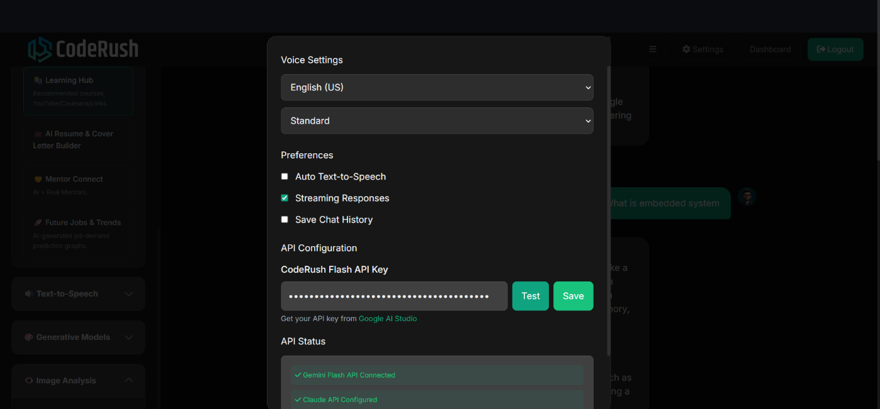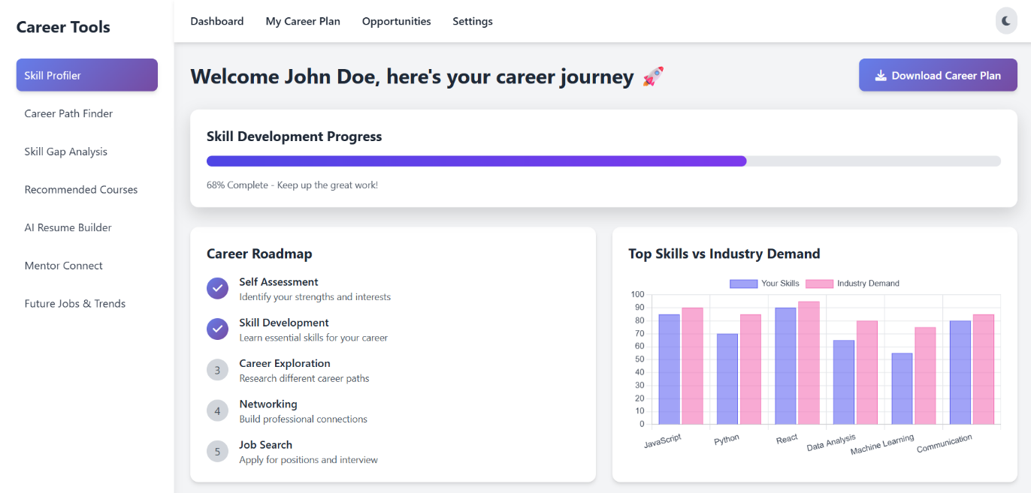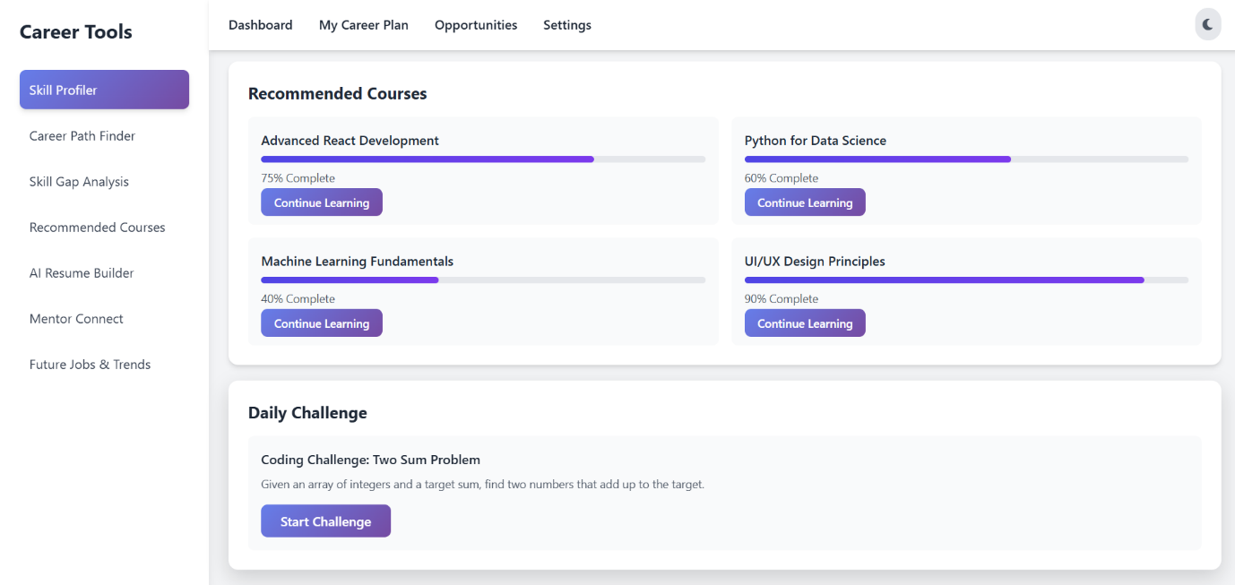

ThankYou..!